**Superintendent’s Corner**

Gary S. Reese, Ed.D.

Interim Superintendent

April 29, 2016

I can’t believe this is the last message for April and we are heading into May. We have entered the final stretch for the school year, but there is still a lot of learning that will be happening!

**Grant Opportunities**

I have continued to work with a number of agencies to develop the following two grants:

The first grant is being awarded through the Department of Justice. It is a grant entitled Comprehensive School Safety Initiative. If received, it will help the schools explore best practices in working collaboratively with local law enforcement and community service agencies to proactively support students and minimize student involvement with the legal system. We are reviewing this grant in collaboration with Pettengill House, Jeanne Geiger Crisis Center and the Amesbury Police Department. We have also reached out to UMass Lowell to determine their level of interest in becoming a research partner in this effort. The conversations regarding this grant have been deep and I am feeling very good about the development of this competitive grant proposal.

The second grant is being awarded through the Massachusetts Department of Elementary and Secondary Education. It is a two year mentoring matching grant with a goal of increasing the number of high-quality mentoring programs as a strategy to assist in closing the persistent achievement gap among Massachusetts youth. We continue to have conversations with NECC about how this grant might supplement the work that is being done through the Early College High School Program.

**A Day on the Hill**

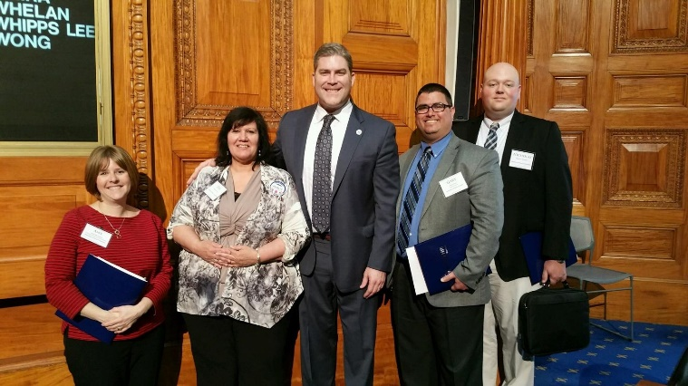On Tuesday, I had the opportunity to spend a day at the State House, visiting with our local legislators and hearing from various legislative officials about bills that will have an impact on education in our community and across the state. This day, called “A Day on the Hill” is an annual event coordinated by the Massachusetts Association of School Committees. In attendance from Amesbury were Deb LaValley, Nicholas Wheeler, Amy Sherwood and myself. The group had the opportunity to speak with Representative James Kelcourse and Senator Kathleen O’Connor-Ives. We also had a conversation with Representative Alice Peisch, Co-chair of the joint committee on education. This was a great event that allowed us to learn about and advocate for our community on topics such as charter schools, Chapter 70 funding, special education, and circuit breaker.

**Leadership Team Work**

Our Administrative Leadership team had two very productive meetings this week. The meetings involved discussions about curriculum development, strategic planning and the effectiveness of our team. Members of the team have been re-energized by these discussions, as they have focused on what is most important to us as educators – our students! Too often, we get bogged down by the administrivia of our work and don’t have an opportunity to engage in meaningful conversations. These meetings are helping to set the direction for work that we will do over the summer and into next school year. Stay tuned for updates on our work.

**New Teachers**

As a culmination to this year’s mentoring program, our new teachers met on Thursday afternoon to celebrate the completion (almost) of their first year in Amesbury and to gain some insight from our retiring teachers as to how to maintain their enthusiasm and momentum in the Amesbury Public Schools. Having the retirees present was a nice way to celebrate both beginnings and endings, and to maintain a link between the over 300 years of institutional knowledge from our retirees.

**Hall of Honor**

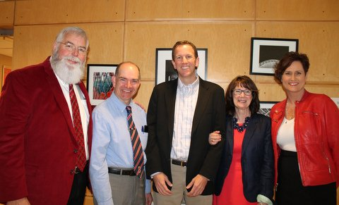On Friday, AEFI (the Amesbury Education Foundation Inc) held its annual Hall of Honor celebration. This event recognizes three individuals that have made a significant contribution to the schools and the community – a former student, a ‘friend’ of education, and a former teacher. This year’s recipients included Brendan Morrissey (Class of 1986 – former student); Officer Tom Hanshaw (Friend of Education) and Linda Young (former teacher). Friday morning, high school students were treated to a powerful assembly where these three individuals talked about their experiences and the importance of a high school education. The overarching message to our students was – “Look what you can do with a high school education from Amesbury High School”. In the evening, we once again celebrated these three talented individuals at the Hall of Honor Ceremony held at NECC. During this evening event, many teacher grants were awarded by AEFI. Of particular note was a grant written by Susan Mroz, which was intended to develop the plans for improving the courtyard at the high school into a learning and calming area. The AEFI board was impressed by this application; in particular, board member Woody Cammett found it to be such a special opportunity that he fully funded the grant for the development, but then also awarded funds to construct the courtyard and to upkeep the courtyard for the next ten years. In total, this grant was awarded for $105,000!!! What a great way to end such a special evening! Thanks to AEFI for the continued support of our schools and a special thank you to board member Woody Cammett for his continued generosity.

Happy May! Be well and have a great weekend!

Gary